Project Development Phase
Model Performance Test

Date | 30 September 2026
Team ID | SWTID-2026-8886
Project Name | Implement Client Script and UI Policy for Incident
Maximum Marks

Model Performance Testing:
Project team shall fill the following information in model performance testing template.
S.No. | Parameter | Values | Screenshot
1 | Solution summary | Deterministic ServiceNow UI behavior; no AI model. | Not applicable
2 | Accuracy | Model accuracy is not applicable; UAT cases define expected behavior. | Not run
3 | Fine tuning | No model fine tuning in scope. | Not applicable

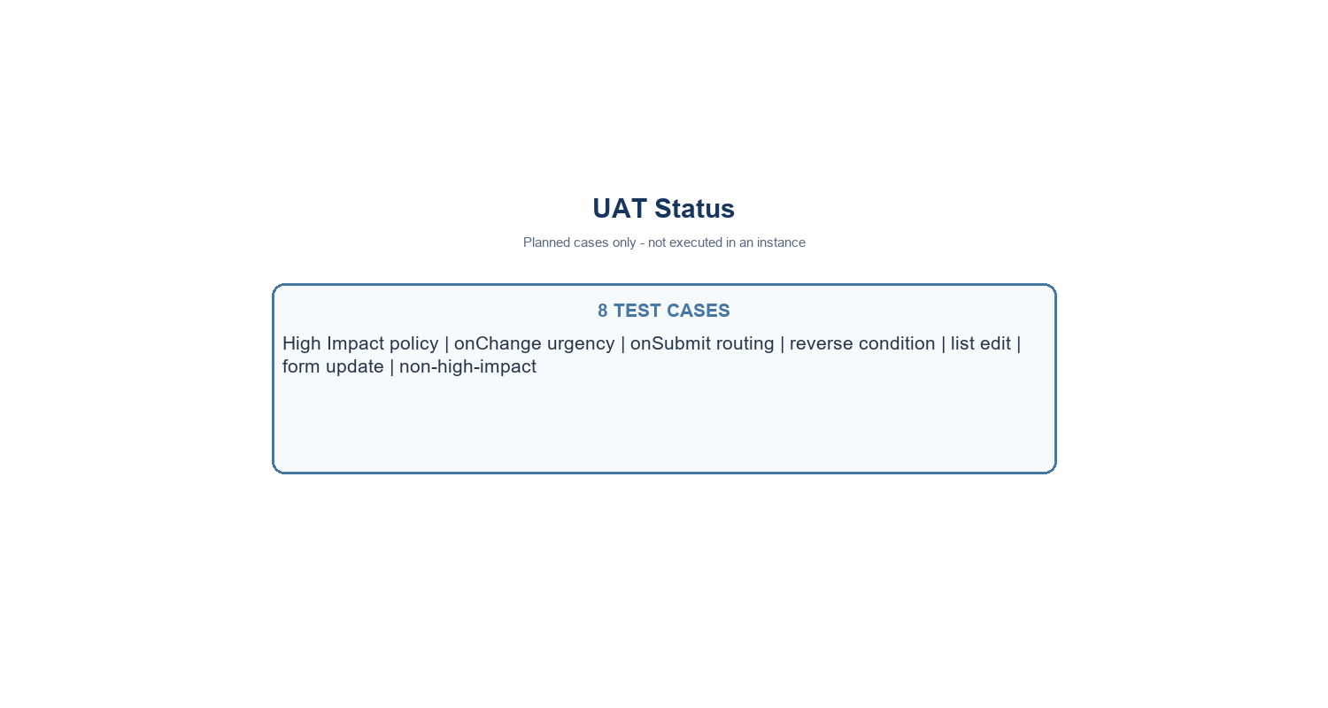
Incident control flow - no AI model used
Project note: values use the standard Incident choices where Impact 1 and Urgency 1 represent High. Confirm field names and values in the target instance.

